Linux
Terminology
Shell – a computer interface to an OS, it exposes the OS to human users and programs called shell since it’s the outer layer of the OS
Terminal – a software program that runs a shell
Bash – the most popular type of shell today
Arguments - some commands will require/can accept arguments like file name, objects and such.
Options – a way to customize a command. Not all of them have this and they can be used more than once in the same command. They are used by writing a dash or writing in a row. Example: ncal -3 -m OR ncal -3mj
Long form options – in cases where the word is long there is either a shorter way to write it like u instead of universal OR you write – example: ncal --universal
Options with parameters – some options require you to write a parameter or else they wont work.
Root - our root folder is called / in Linux and houses every other folder
Home – the folder where all our users are housed
Absolute path – a path that starts from our root directory to anywhere, you go down from root to the folder using cd when your trying to get there example: cd desktop/dop from anywhere in the pc will get me there

Commands
clear - cleans the terminal
date - gives you the time and date
cal - shows you a horizontal calendar
ncal - shows a vertical calendar
man – lets you see the manual of the command example: man ncal
echo – lets you copy a string
which – tells you where a command is located
help – works like the man command but for shell-built commands
type – shows what type of command it is
pwd – shows us where we are in the terminal/folder system.
Ls - will list the content of a directory. Which means if done while in file will list what's in its options: ls -l: shows you the full files
cd - lets you change directory options: cd .. – lets you go back
touch – creates a file for you in the directory your in
file – shows what type of file something is.
Mikdir – lets you create a folder.
Nano – a program in Linux that lets you edit file control + o = saves control + x = exits
Rm – lets you delete files
Rmdir – deletes empty directory's
Rm – r – deletes your directory and whatever is nested in it recursively
Mv – lets you move files to whatever directory you tell it to. Bu writing a new name after the file you change its name.
Cp – lets you copy a file
History – shows you the history of commands you have run. ! + number – lets you use the number given by history so you can see what the command has done and copy it
Cat – lets you print out the contents of a file
Less – lets you see less of a long file, that way its easier to read
Tac – prints the file from the last line to the first
Rev - prints the words in reverse
Head – prints the first 10 lines
Tail – prints the last 10 lines
Wc – prints the number of lines – words – bits in the file in this order
Sort – prints a sort of the letters in alphabetical order -r for reverse -u for only unique -k lets you sort by column -n is numerical
Tr – lets you change or remove (by using -d) a syllable of a sentence
Tee – if put in a command line between two pipes will save the info given after pipe 1 then pass it too pipe 2
locate – allows you to find any files on the pc using its syllables or words case sensitive unless -I is used
find – works like ls but also shows nested files and folders -type f will only show files and -type d will do the same for directories
-type f will only show files and
-type d will do the same for directories
-name will search by name
-size will filter by size
- user filters by user
-empty looks for empty files/ directories
Mmin – allows us to see the time since file was modified +30 = more than 30 min ago
Cmin – allows us to see time since file was changed
Amin – shows time since file was read by an application or command
Xargs – packages the info given to it by a command and moves it to another, used like exec at times when a command cant be piped forward BUT runs one time will exec runs every time so is more efficient
Grep – allows us to search inside files example: grep "chapter" greatgatsby.txt will find us all chapters in the file
Chmod – allows us to change permissions for users, groups and world
Su – lets you switch users from the terminal
sudo – allows us to run commands as the root user
Chown – lets us change who owns a file, to change for groups you use : before the name of the group. To change user and group owner you write both:
Chown :horses file.txt = change the file group owner of file.txt to the user to horses
Chown bojack:horses file.txt = change the owner of file.txt to the horses group and the owner of the group will be BoJack
Printenv – lets use print that environment better to pipe to less to be easier to read
PATH – allows us using the command $path to see all the directory routs on a machine

File editing
Nano – a program in Linux that lets you edit file
control + o = saves
control + x = exits
control + g = help page
control + w = search file
M = meta key = alt

Shortcuts
Control + L = clear
Control + A = moves you to the start of the line
Control + E = moves you to the end of the line
Control + f = go fast forward
control + b = go fast backward
alt + f = jump one word forward
alt + b = jump one word backward
control + t = swaps two letters that are in a row
control + k = removes everything in the line after your cursor
control + u = removes everything before your cursor
alt + d = removes the word in front of your cursor
control + w = removes the word before your cursor
control y = lets you revive the latest thing you removed
control + r = lets you search through your command history by typing it.
Redirecting
Redirecting – changing the place where an input or output goes
Standard output/1 – normal stream of output that we can control, on default goes to terminal using > you can change the location of the output but it does replace what was already in the file before.
Standard error/2 - the error massage, default goes to the terminal using 2> you direct it to another file
Standard input/0 – we pass a file back to our command/terminal as data using <
Appending – just like standard output only that it adds without replacing to a file using >>
Combo: while using together it reads from left to right using every function one at a time example: cat < cat.txt > sounds.txt will give the cat command the data from cat.txt and then it will redirect it into sounds.txt, we moved whatever is in cat into sounds.
Shortcuts - 2>&1 or &> = redirect both error and output to the same file
Piping
Difference between piping and redirecting - Redirecting is done from a command to a file while piping is done between two different commands
Pipes – allow us to connect the standard output of a command to the input of another command using |
Tee – if put in a command line between two pipes will save the info given after pipe 1 then pass it too pipe 2

Wildcard characters
* - the * allows us to call groups of files. For example, if we want to call all files ending in .html we use *.html we can use that in the middle of words too example: blue* means all files starting with blue
? – lets you search for files with only one character before the . example log?.css will bring back log1.css, log2.css log3.css but not log23.css since its two characters. Every ? you add is another character, so ?? will bring log.23.css but not the rest.
Let's you set parameters for what you want to move such as [0-9] - [ ]
Will negate what is in the brackets example: [^1-9] anything but - [^ ]
~ - expands to home directory
{ } – allows you to generate strings fast: touch {sun,mun}.txt creates two files sun.txt mun.txt
$ - allows us to do math echo $((12/3)) it will print 4 or allows you to run commands in echo like $(date)
" " – looks at what's written as a string BUT special characters are still looked at as commands, to ignore that must use single quotes ' '
Not – or – and – used like in CS to specify what you want a command to do or don’t
Finding files and timestamps
Ls - will list the content of a directory. Which means if done while in file will list what's in its options: ls -l: shows you the full files
locate – allows you to find any files on the pc using its syllables or words case sensitive unless -I is used
find – works like ls but also shows nested files and folders types:
-type f will only show files and
-type d will do the same for directories
-name will search by name
-size will filter by size
- user filters by user
-empty looks for empty files/ directories
Mtime – shows last time file was modified. shown in ls -l =mmin
Cmin =Ctime – changes anytime mtime changes but also when file is renamed, moved or altered permission
Amin =Atime – changes every time an application reads the file or a command does (like cat)
Exec – allows us to add a command to find (like piping) example:
find -name "*broken*" -exec rm '{}' ';' = means that every file with broken as its name will be deleted. Good to use with find
Xargs – packages the info given to it by a command and moves it to another, used like exec at times when a command cant be piped forward BUT runs one time will exec runs every time so is more efficient. Good to use with find
Grep command
Grep – allows us to search inside files example: grep "chapter" greatgatsby.txt will find us all chapters in the file
-w = will show you only the word itself and not if what you wrote is a part like ate in whatever
-r = lets you search recursively and in nested directory's
-I = makes it case insensitive
-c = counts how many time a word is used
-B = shows you a line or more before the match
-A = shows you a line or more after a match
-n = shows you the line number of what your searching for
-E = lets you use regular expression signs like ! or ?
. - matches any single character
^ - matches the start of a line
$ - matches the end of a line
[abc] - matches any character in the set
[^abc] - matches any char NOT in set
[A-Z] - matches characters in a range
* - repeat previous expression 0 or more times
\ - escape meta-characters
Permissions
Group owners – allows us to give a groups of users permission to edit files
File types(first character in name):
- = regular file
B = block special file
D = directory
C = character special file
l = symbolic link

to know the permissions we need to understand how to read it:
1. the first letter is the file type
2-4. the next three characters show us what the owners permissions are
4-6. shows us what the groups permissions are
6-8. the permissions of everyone else
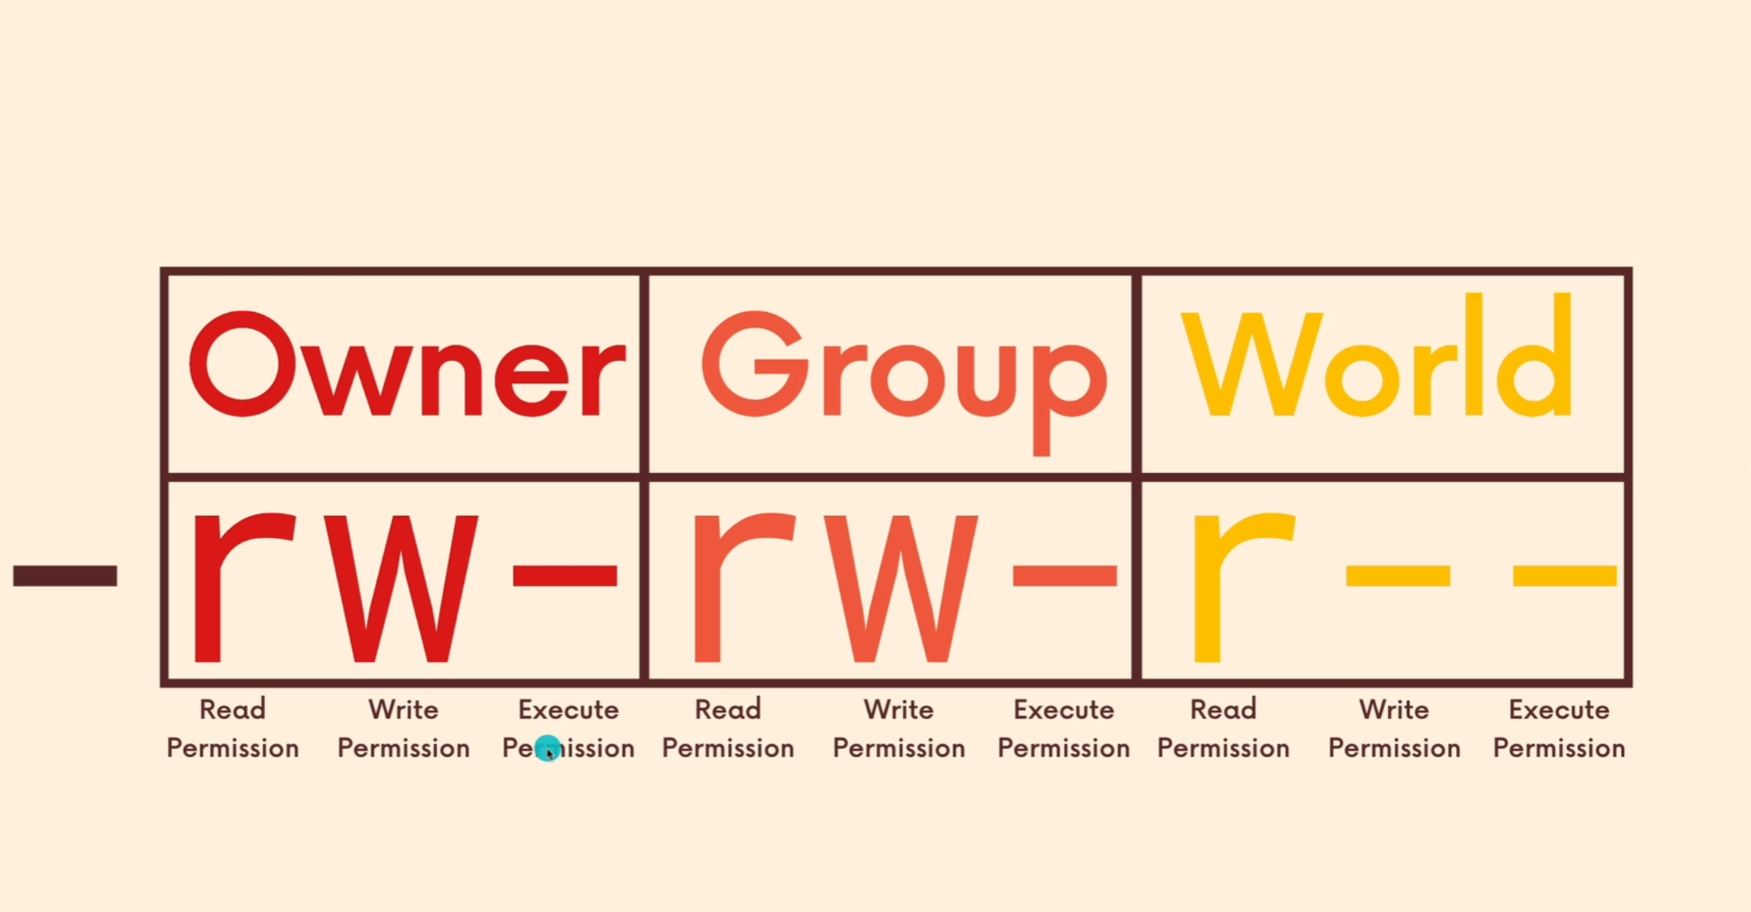

- if there is a dash they are not allowed to do whatever that place should do
r = read permission = allowed to read file or directory
w= writing permission = allowed to rewrite and delete the file
x = execute permission = on directory's allows you to cd into it, and with files allows you to execute it as a program
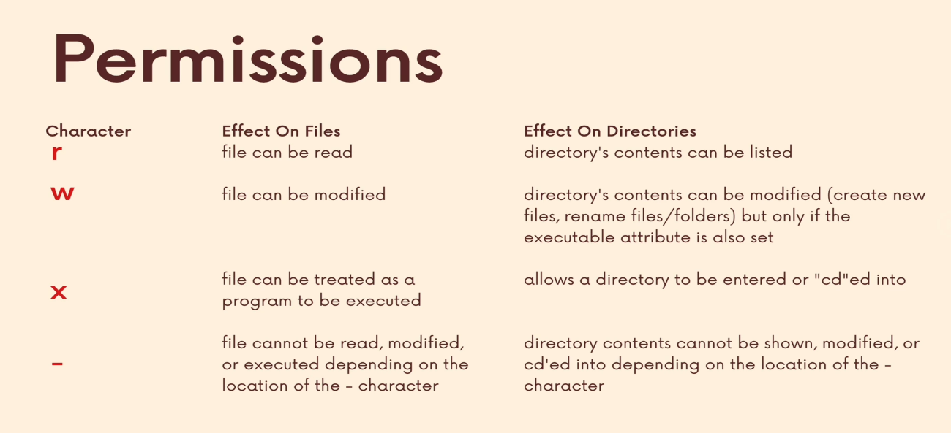
Chmod – allows us to change permissions for users, groups and world
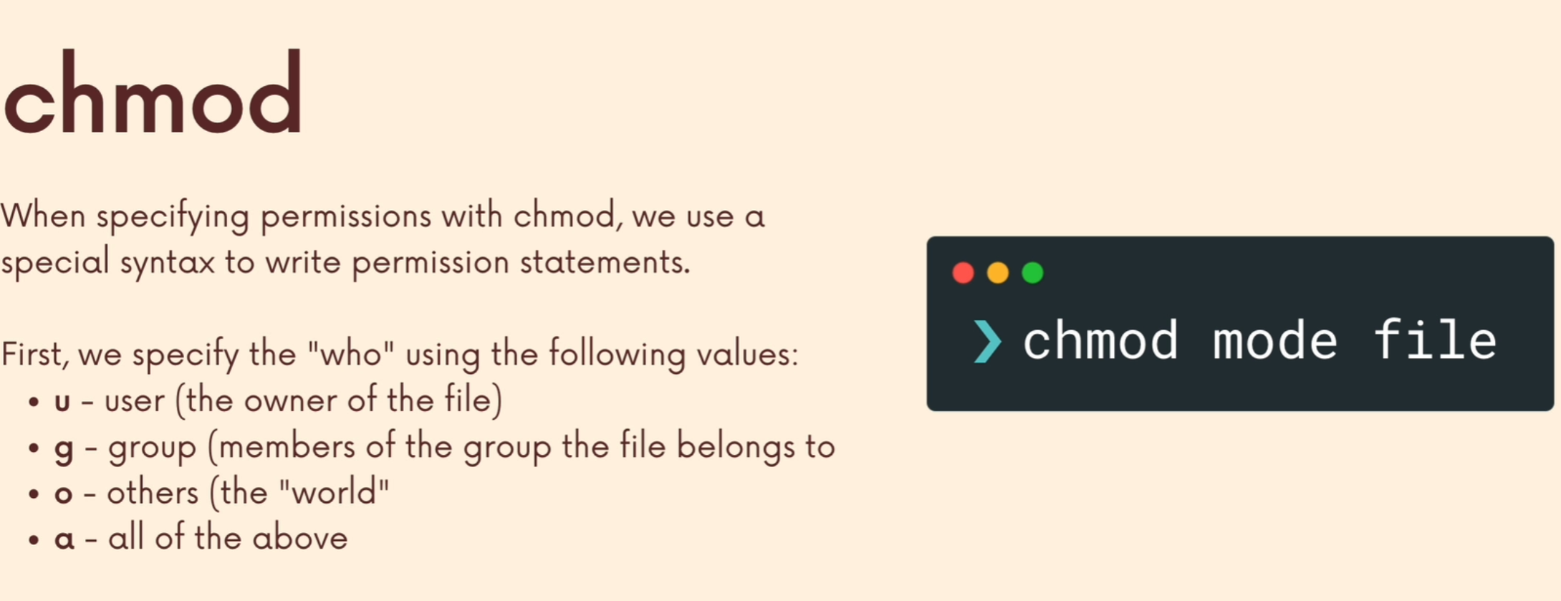
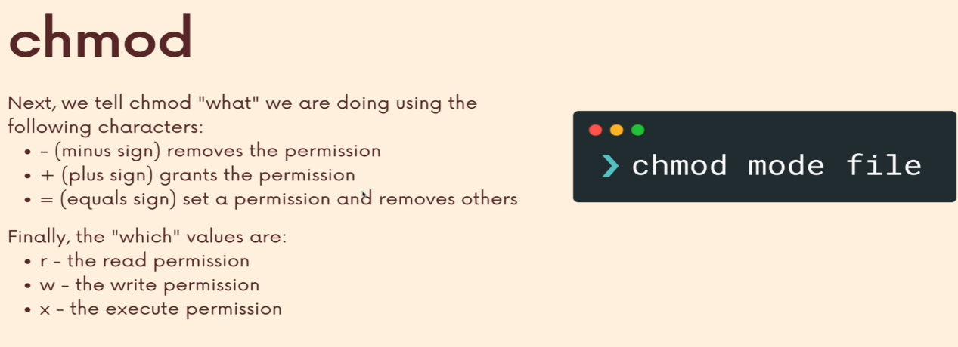
Example: chmod u+x file.txt = add execute permission to user
Another possible way to use the chmod command is using octal numbers:
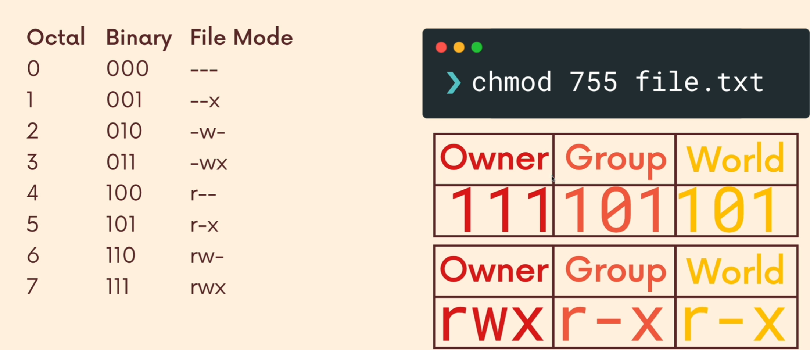
Su – lets you switch users from the terminal
sudo – allows us to run commands as the root user
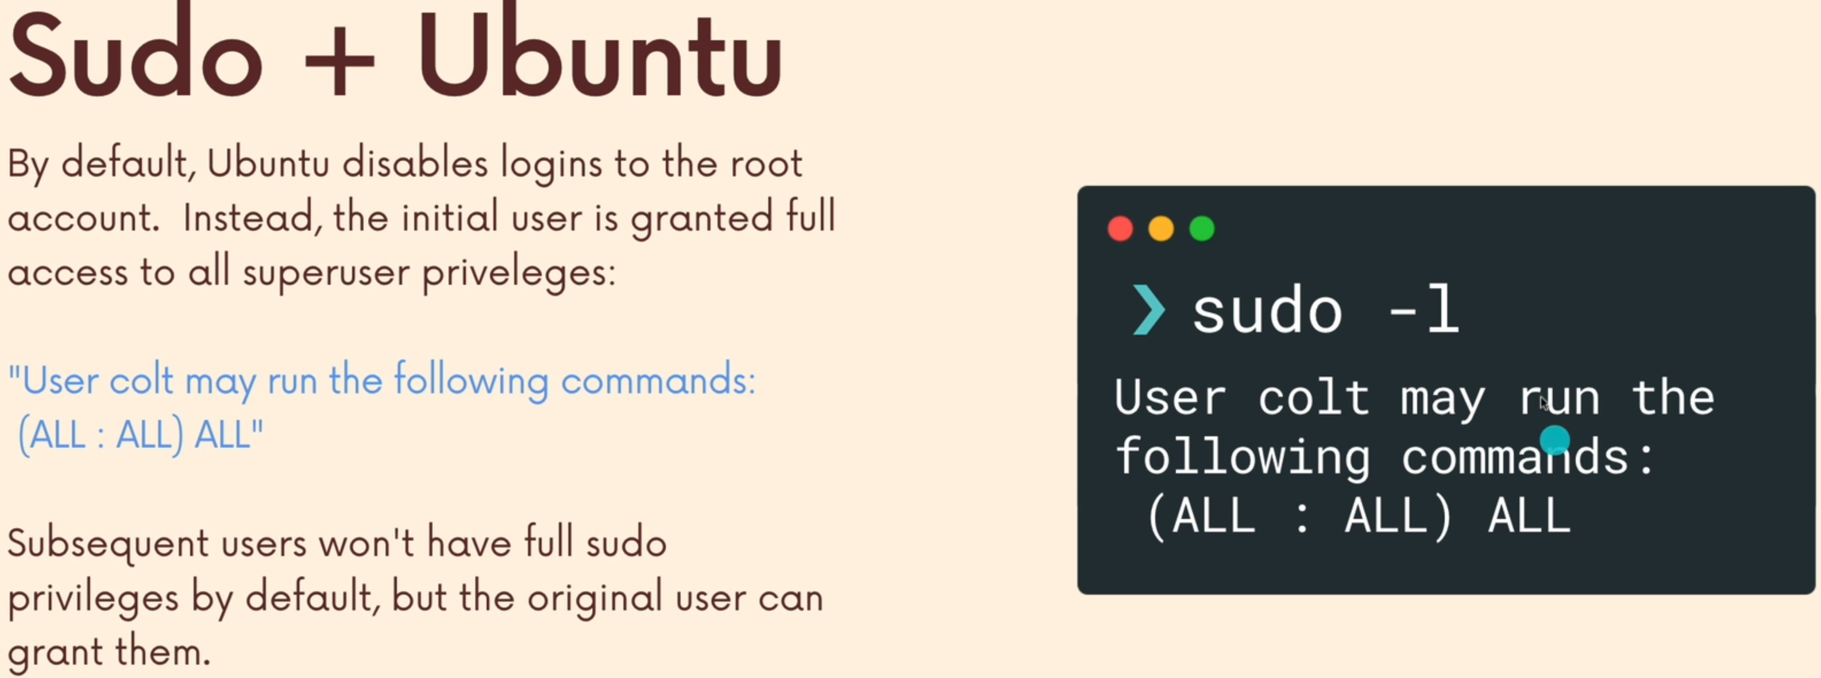
Chown – lets us change who owns a file, to change for groups you use : before the name of the group. To change user and group owner you write both:
Chown :horses file.txt = change the file group owner of file.txt to the user to horses
Chown bojack:horses file.txt = change the owner of file.txt to the horses group and the owner of the group will be BoJack
Group – allows you to see the groups that were created
Addgroup - lets you create a group
Adduser – lets you add a user to a group

The shell environment
Environment – the main shell terminal and what's in it while a current user is logged in, changes between each one. The variables in it are always in all caps and can be referenced using $ to pull data out of it
Printenv – lets use print that environment better to pipe to less to be easier to read
Defining a variable – it is possible to create our own variables in the Linux environment, example: animal = dog so from now everytime we echo animal it prints dog, the variable created is only available in the terminal it was created in and does not save between sessions or terminals
Aliases – allows us to create variables that call upon commands, example: alias animal_number = sort wc -l animal.txt = now when we call upon animal_number it will tell us the number of animals in that file.
Bash scripting
Scripting – means writing a file of code using bash that we are later able to execute using the bash command
Shebang – the first prompt of a bash script should always be #!/bin/bash OR whatever the path to our language is. So if its python then the path to python3
PATH – allows us using the command $path to see all the directory routs on a machine
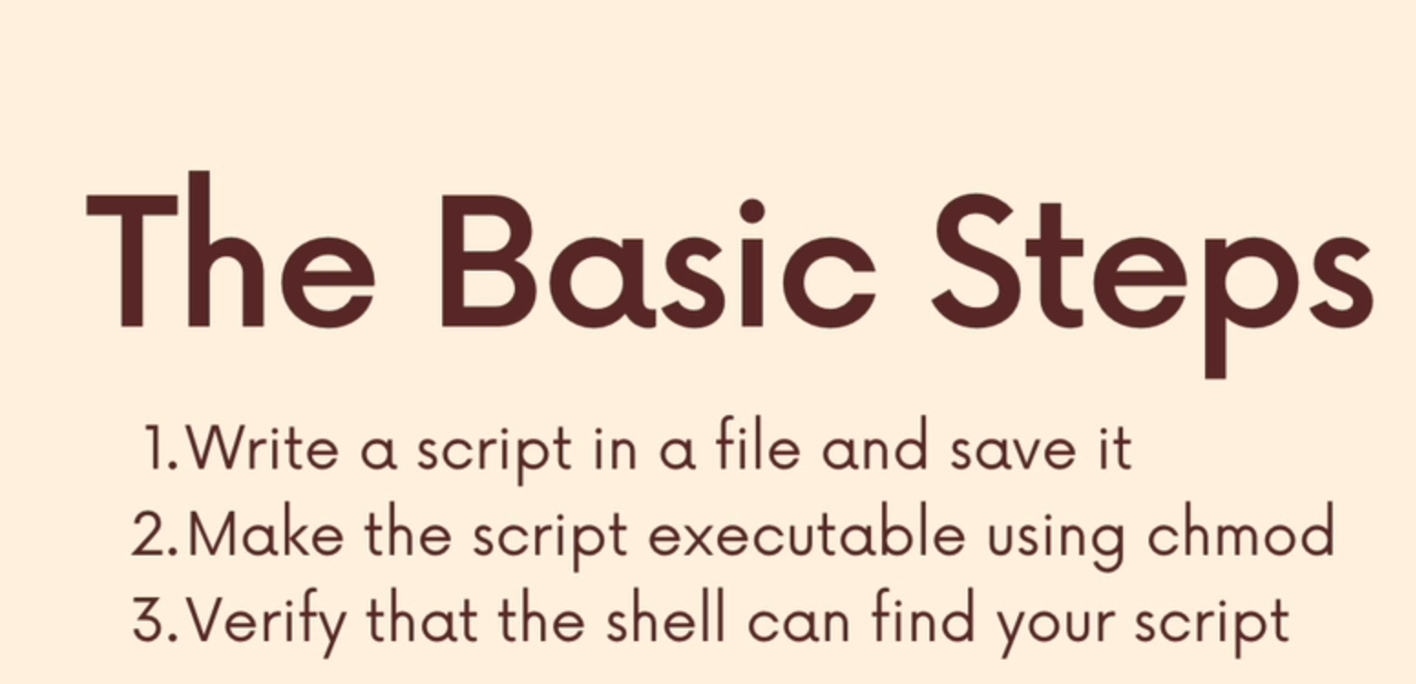
Cron
Cron – allows us to schedule commands using the cronjob -e command
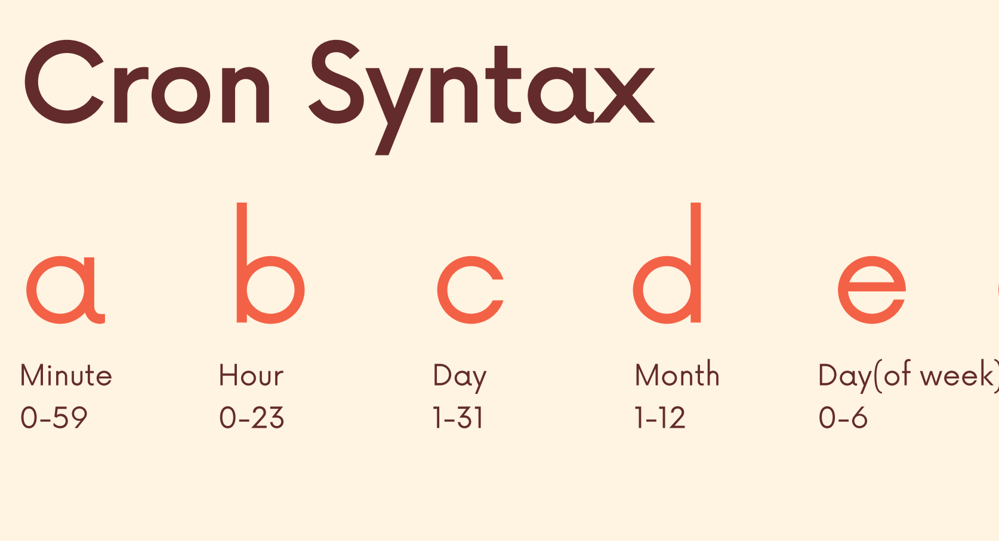

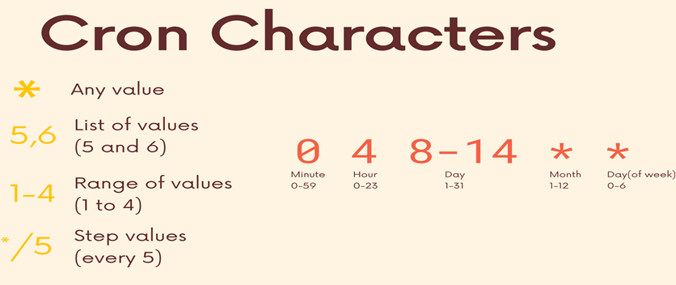
So for example, if you wanted to run a command every Monday at 6:30 it will be written like this 30 6 * * 1 echo file.txt. now the 6:30 means every 6:30 AM not six anda half hours. If we want something to run every x time we use / before it so /5 in the minutes mark will run every 5 minutes
How to write a cron job:
1. use command cronjob -e to get into the Nano file
2. scroll to the bottom and write the job under the comments

